- Q 1 & Q 2 & Q 3
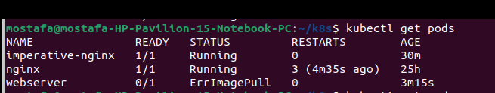

- Q4
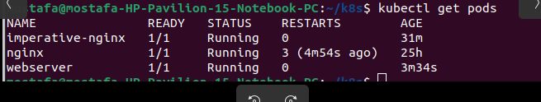
the yaml-file
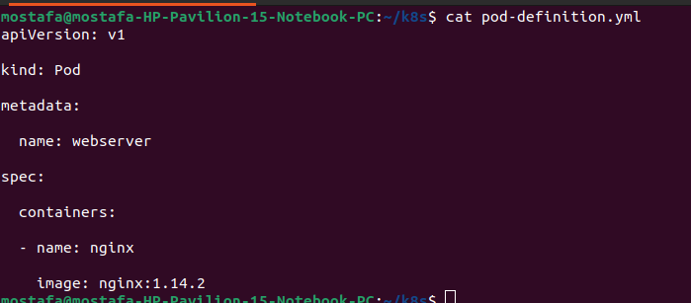
Q 5 : How many pods are running in the system? Type the command to show this

kubectl get pods

Q 6 : - What does READY column in the output of get pods command indicate?
the readiness of containers in each pod

Q 7: Delete first pod named imperative-nginx you just created. Type the command to do this
# kubectl delete pod imperative-nginx
Q 8 : Which node is pod named webserver running on (list two commands to do this)
=

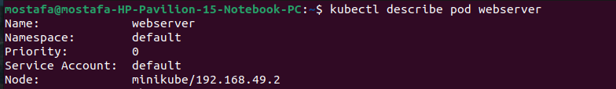
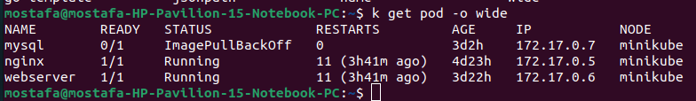
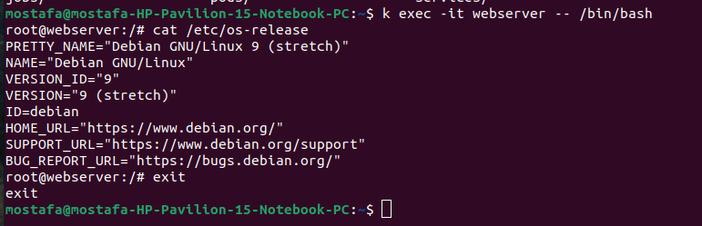
Q 9 & Q 10 & Q 11 :
Q 12 :
kubectl logs webserver
# dump pod logs (stdout)
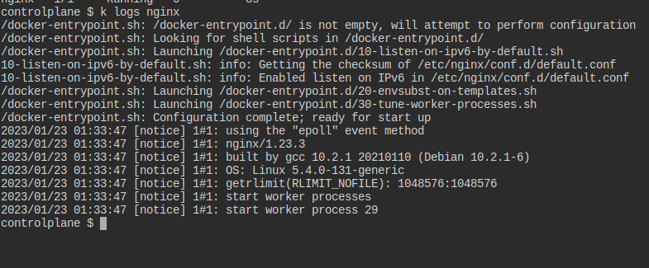
Q 13 :
Q 14 :
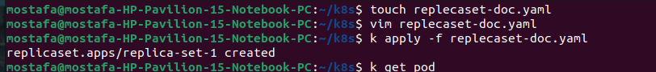
Q 15 :
Q16 : 5 pods
Q 17 : 5
replecaset update it.

